Questions for examination

Theoretical questions (2 questions)

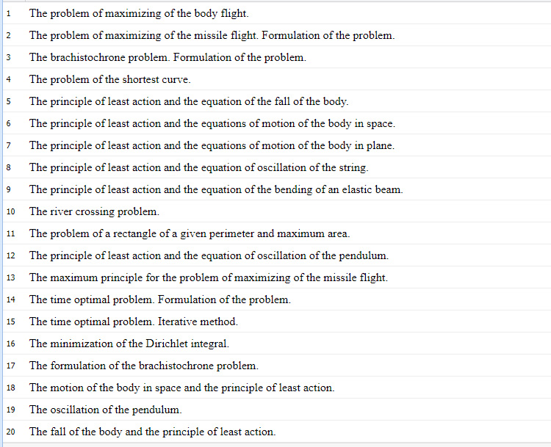
21. Variational inequalities.
22. Inverse problems. Idea.

Practical questions (1 question)
- Extremum of functions and stationary condition.
- Lagrange problem and Euler equation
- Lagrange problem with many unknown functions
- Lagrange problem with high derivatives of unknown function
- Variational problem with unknown function of many variables and Ostrogradsky equation
- Bolza problem and transversality condition
- Variational problem with isoperimetric condition
- Variational problem with pointwise condition
- Optimization control problem and maximum principle, iterative method
- Optimization control problem with fixed final state, iterative method

